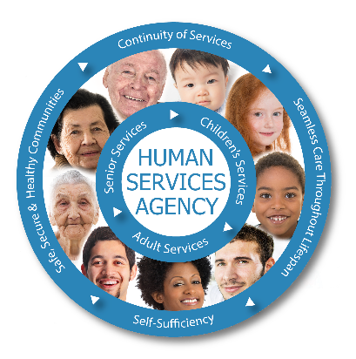 |  | Respite / DCSM Checklist  Before providing respite for any child, you must first have permission from your licensing worker. Additionally, the foster parent asking for respite must have permission from their licensing worker.  Things to consider:  - Do you have the space in your home to accommodate more children?  - Do you have the space and car seats available to accommodate more children in your vehicle?  What to ask the resource parent and/or worker prior to providing respite:  - Any appointments for the child(ren) while in your care:  - Medical:  - Dental:  - Therapy:  - Psychiatric:  - PSR/BST:  - PT/ OT:  - Allergies / Dietary restrictions:  - Medication(s):  - Visitation – days, times, parents visits together or separate, sibling visitation  - School/Daycare & transportation:  - Important boundaries/triggers, behaviors and/or supervision requirements:  - Routines in home where they currently reside:  Contact information  Child(ren)’s Case worker:  Phone number: Email:  Child(ren)’s Therapist:  Phone number: Email:  Child(ren)’s Attorney:  Phone number: Email:  Placement & Support Specialist for any respite questions:  Heather Wenker  hwenker@washoecounty.gov
Dates requesting:
Child’s Name:
DOB:
Child’s Name:
DOB:
Child’s Name:
DOB:
Resource Parent:
Contact information:

AFTER HOURS NUMBER:
833-900-SAFE (7233)

Medical Unit
775-284-2763
2097 Longley Lane

FEC
775.352.3230
905 E Prater Way

Resource Parent Head Quarters (HQ)
775.337.4488
2395 East Prater Way

WEBSITE:
www.washoecounty.us/hsa
www.jitnevada.org

